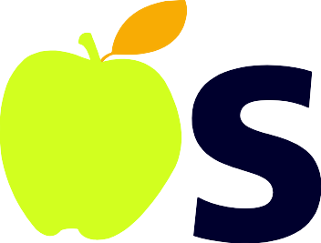

Homeschool Reimbursement Process

NOSF requires all family’s to submit all receipts for each child as one family reimbursement. We then divide this total per child and you receive the same amount per child. The maximum reimbursement is $750 per child for the year.

- Save all receipts for acceptable expenses purchased throughout the year.
- You can submit copied or original receipts by
- mailing to the NOSF office
- Email (in pdf form please no pictures of receipts) to info@nosf.org by the deadlines in November and February.

- Know your families eligibility percentage amount from the award email you received.

- For example: if your family qualifies for 25% each child will receive 25% back of the total purchased amount up to $750 per child.

If you have further questions on the reimbursement process feel free to contact the NOSF office by phone 419-720-7048 or email info@nosf.org

